**Instructions**

* Save your file as surnameforename.html.
* Use embedded style sheets.
* Once you have completed the exam, email your file to [anne.obrien@staff.ittralee.ie](mailto:anne.obrien@staff.ittralee.ie)
* Do not leave until I have received your exam.
* Please keep a copy of the exam until you get your results back.

**Screen Capture**

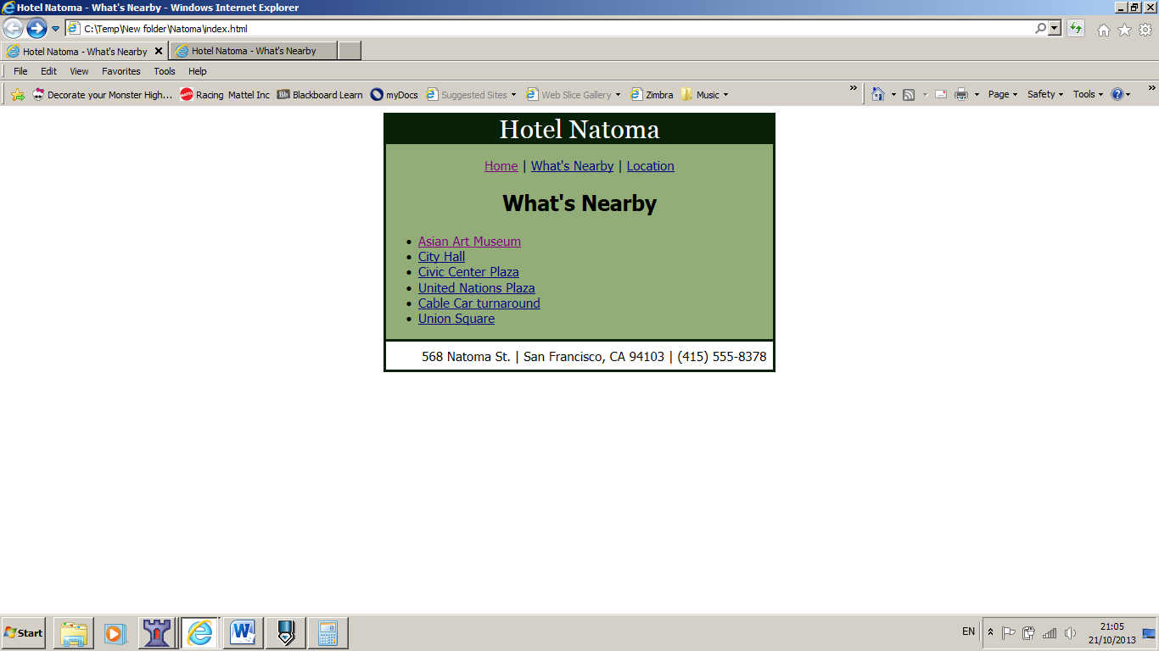

**Links**

Asian Art Museum should link to: http://www.asianart.org/

Location: Based on the chart below and presuming you are in index.html, what would be the relative link to location.html

What’s Nearby: Based on the chart below and presuming you are in index.html, what would be the relative link to nearby.html

For all the other links just leave the “ ” empty.

**Text**

# Hotel Natoma

Home | What's Nearby | Location

## What's Nearby

* Asian Art Museum
* City Hall
* Civic Center Plaza
* United Nations Plaza
* Cable Car turnaround
* Union Square

568 Natoma St. | San Francisco, CA 94103 | (415) 555-8378

**Settings**

Font for the body is: tahoma, verdana, arial, sans-serif

Heading font: georgia, "times new roman", times, serif

Background colours used are #082008, #93ad78

Main box has a width of 480px